**Koyl Embedded Launch Epic User Manual for testing during development**

**Login:**

**Open Epic Login Url:** **https://open.epic.com/Account/LogOn**

Select the Epic UserWeb option (Ticked one):

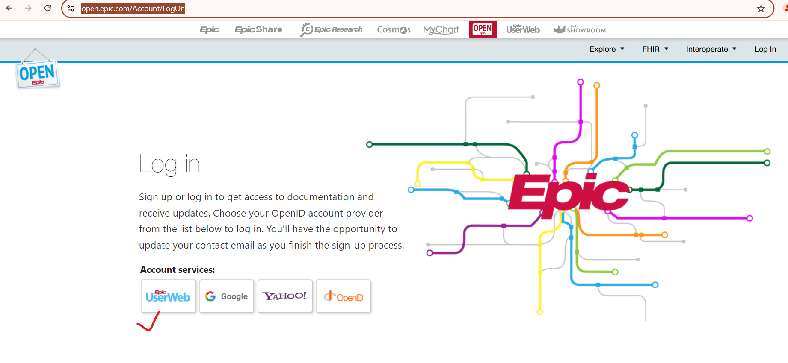

**Epic Login details:  
Username: abhishek.techbit  
Password:** **Testing@123**

**Now open the (**[**https://fhir.epic.com/**](https://fhir.epic.com/)**)**

Now click on **Documentation** drop-down and select Launching your App from Epic.

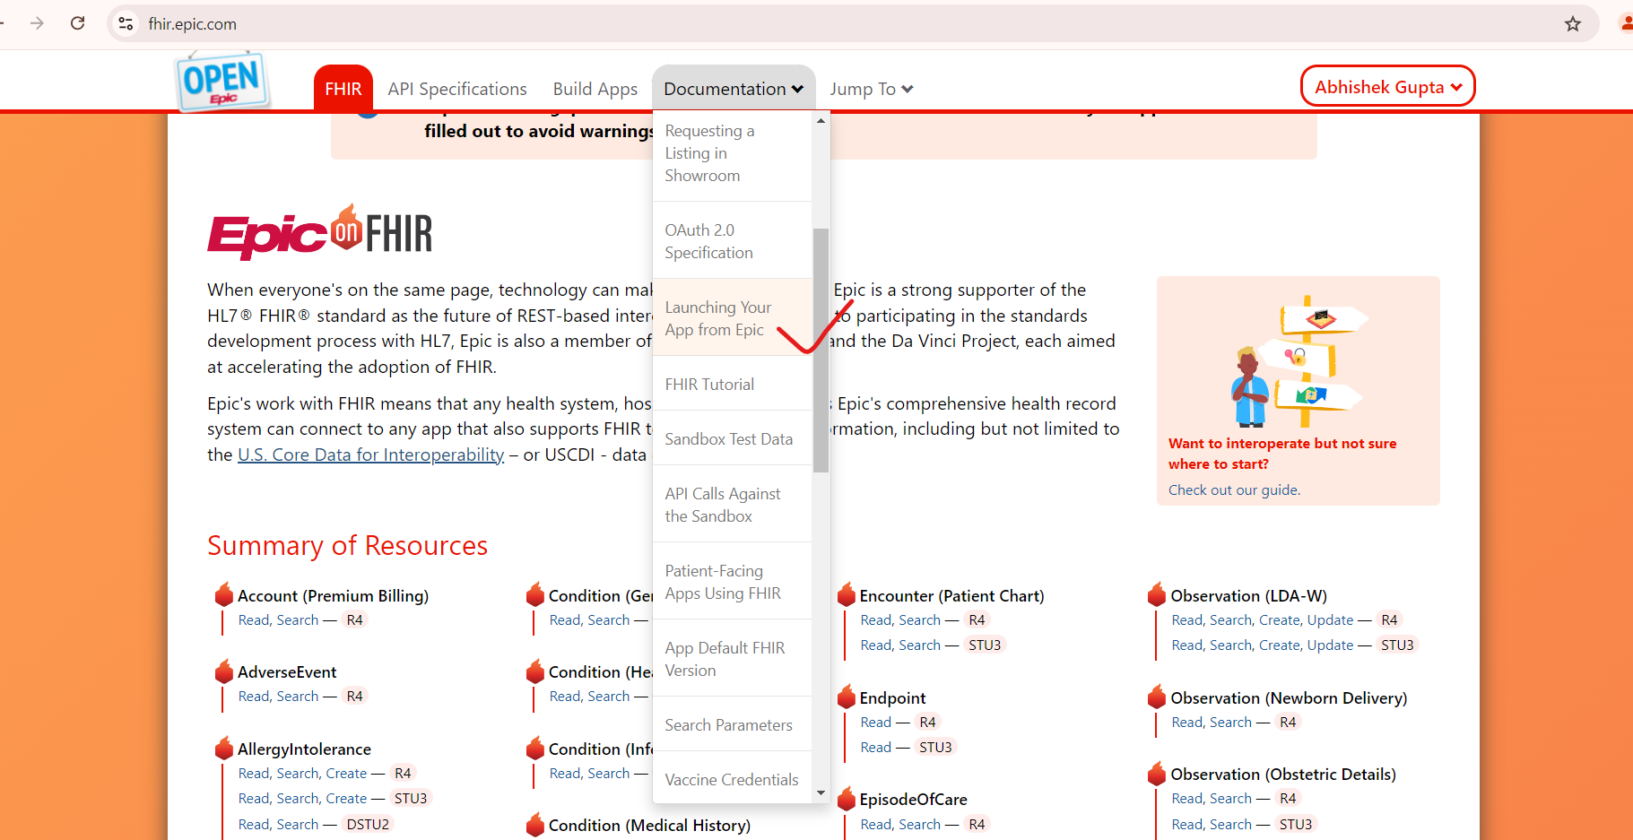

Now click on **Try It** button.

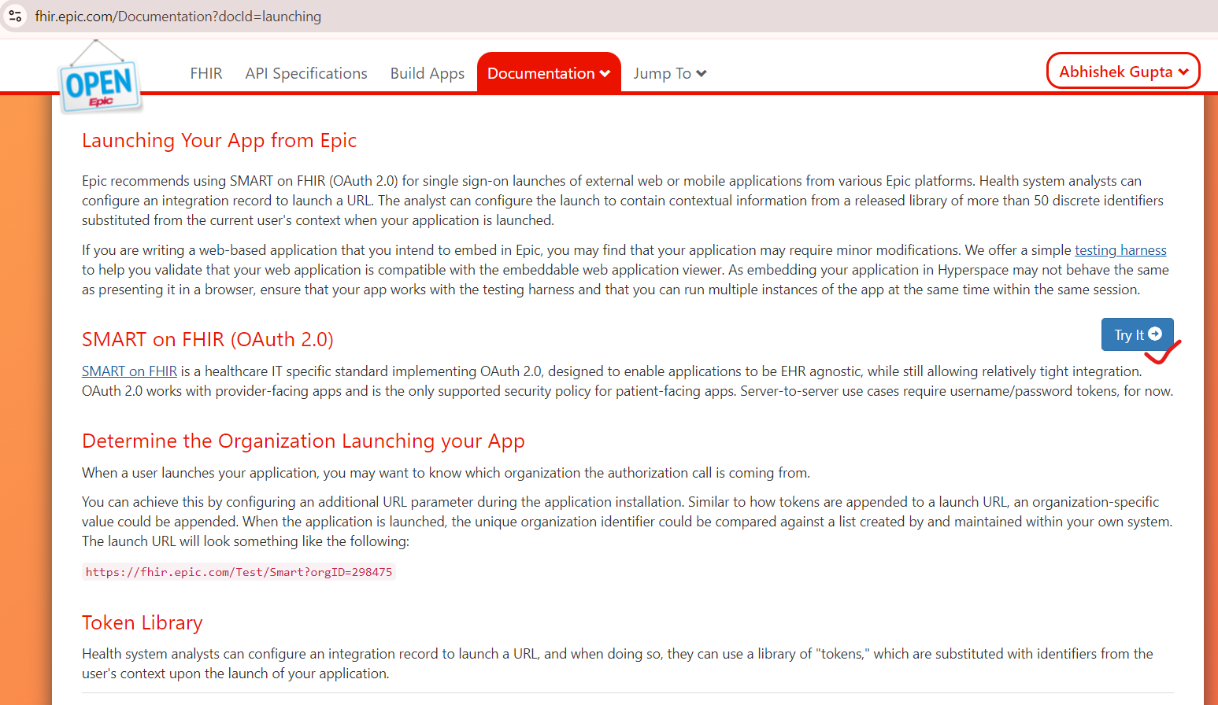

On clicking try it a popup will open  
From here select Specific app (For the current scenario please select the highlighted one )

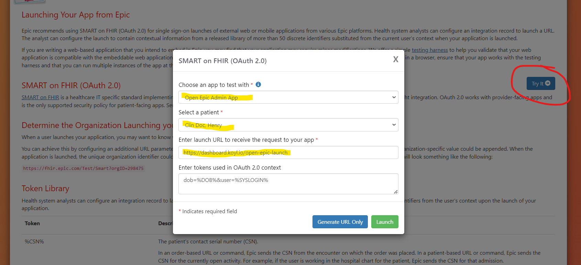

Please provide Launch URL of your Application (At present use this one [**https://dashboard.koyl.io/open-epic-launch**](https://dashboard.koyl.io/open-epic-launch))

Now click on Launch button then you will be redirected to another tab and wait for few seconds (approx 10 to 15 sec)

